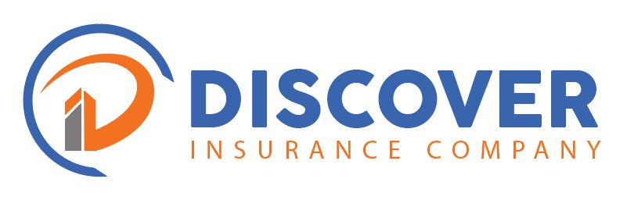

TO: NARAYNA R TUMMALA
OCCUPATION: TBA.
FROM: DISCOVER INSURANCE COMPANY
DATE: 23RD SEPTEMBER 2025
AGENT: DIRECT
PERIOD: 12 MONTHS

QUOTATION VALIDITY PERIOD:
Fourteen Days (14). This is a quotation only, and it is not the intention to HOLD COVERED unless specifically endorsed in writing.
CLASS: Motor Comprehensive. ________________________________________________________________________
We refer to your above request and based on the information provided we are glad to quote as below.
We trust you will find this to be in order and should you wish to discuss our quotation, please do not hesitate to contact us.
Kind regards,
Cecilia Kalenga
Underwriter
Discover Insurance Company
E-mail: cecilia@discoverinsurance.co.zm

MOTOR COMPREHENSIVE INSURANCE
Defined Event : Loss of or damage to interest insured or legal
Liability to third parties for bodily injury,
death and property damages
Interest Covered :
Total Sum Insured : USD22,000.00
Rate : 5%
Basic Premium : USD1,100.00
5%Levy : USD55

Total Premium : USD1,155.00

Standard Third-party Liability Limits
Bodily injury/Death
Any one person - ZMW 55,000.00
Any one event - ZMW 100,006.50
Property damage - ZMW 30,000.00

Excess
: 10% Minimum ZMW 1,000 each and every claim for own damage.
15% Minimum ZMW 1,000 third party property damage claim.
20% Minimum ZMW 1,000 for all theft claims.
20% Minimum ZMW 1,000 for young drivers (Less than 22 years old)
And inexperienced drivers (under 2 years).

Extensions
: Automatic Additions- within 30days of purchase and
additional premium.
: Foreign use (COMESA/SADC)-Subject to applicable rates.
: Towing costs-reasonably incurred but limited to ZMW 1,500
: Equipment/Accessories- Limited to ZMW 2,500 per vehicle.
: Medical Expenses- ZMW 1,500.00 per event.
Exclusions
: Consequential loss of any kind.
: Unlicensed drivers.
: Driving under the influence of alcohol/Drug.
: Claims arising from contractual liability.
: Damage to tyres due to application of brakes.
: Theft by driver employed by the insured or family member of the driver.
: Depreciation, Mechanical or electrical failure or breakage.
Claims
: Acknowledgement of claims notification to be done within 24
hours of receipt of the notification.
: Inspection of damages/losses to be carried out within 48
hours of notification.
: Appointment of a Motor assessor within 48hrs.

